**Day-13 Assignment**

**Name: Kanak Agrawal**

**Email:** [**Kanakagrawal2001@gmail.com**](mailto:Kanakagrawal2001@gmail.com)

**Date:06-02-2024**

**Question: Here is the hand written notes for today’s class**

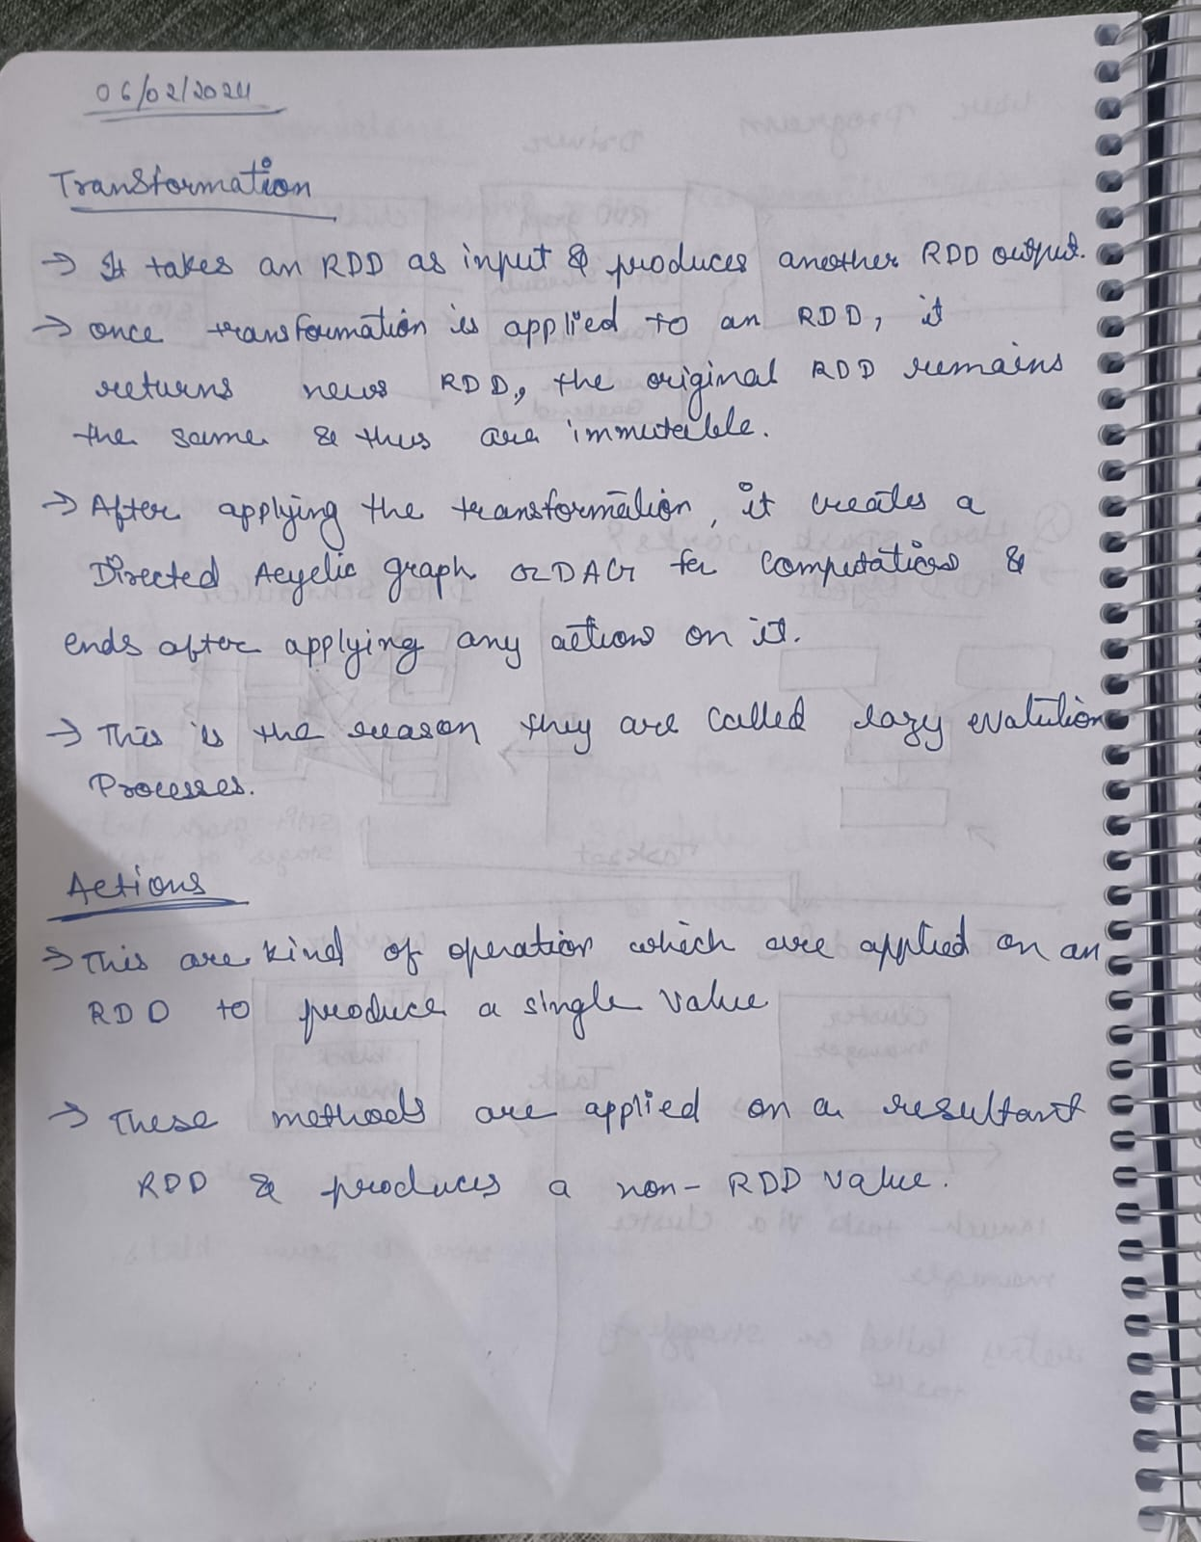

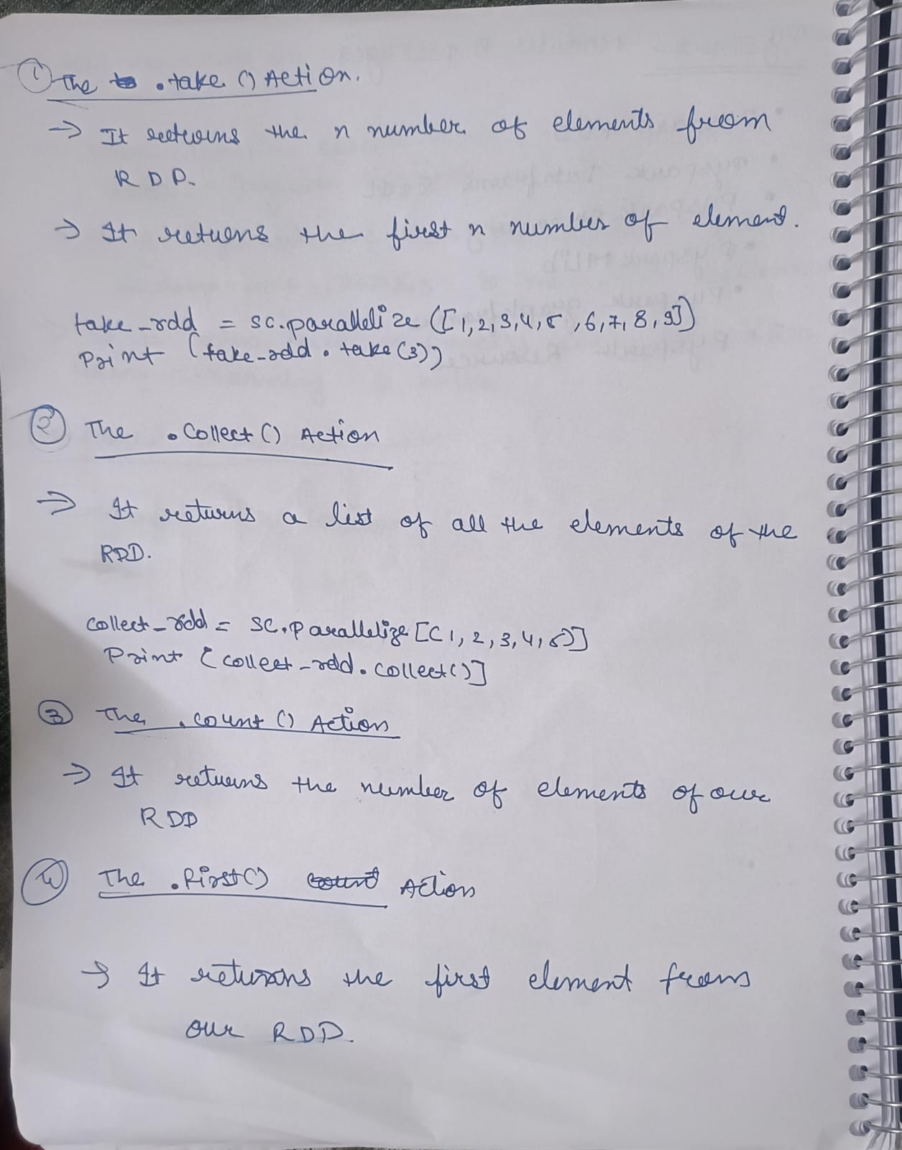

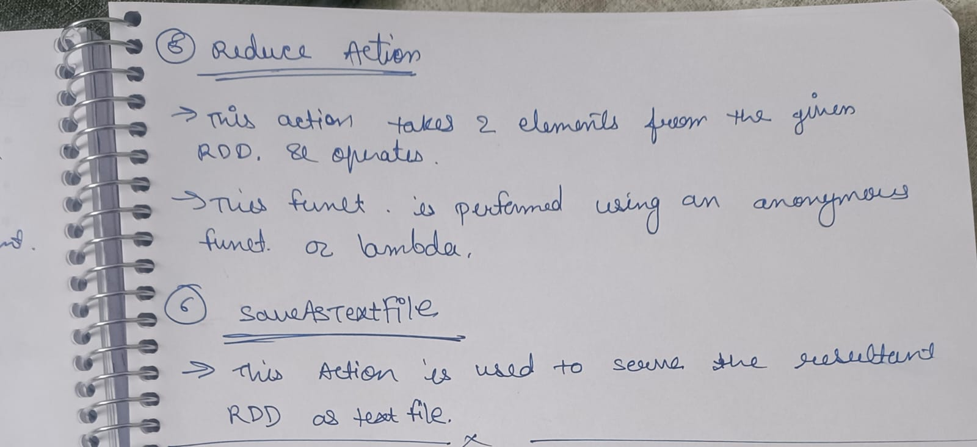

* **Actions In pyspark RDDS**

1. **The. Collect () Action**

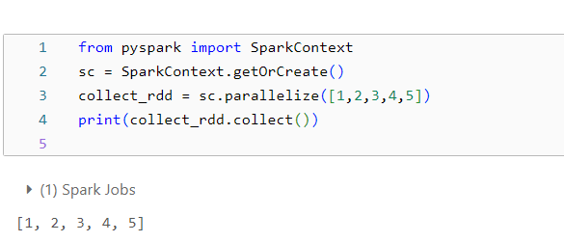

1. **The .Count () Action**

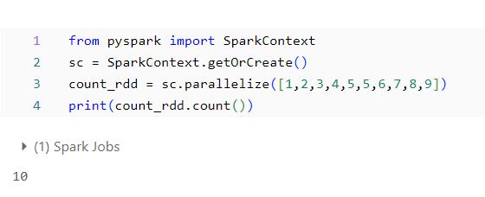

1. **The .first () Action**

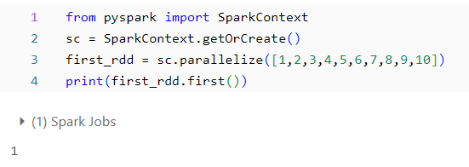

1. **The .take () Action**

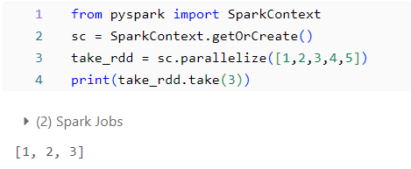

1. **The .reduce () Action**

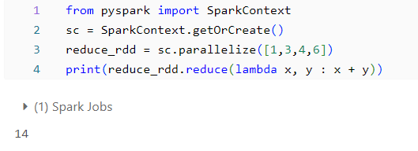

* **Renaming data in pandas dataframe**

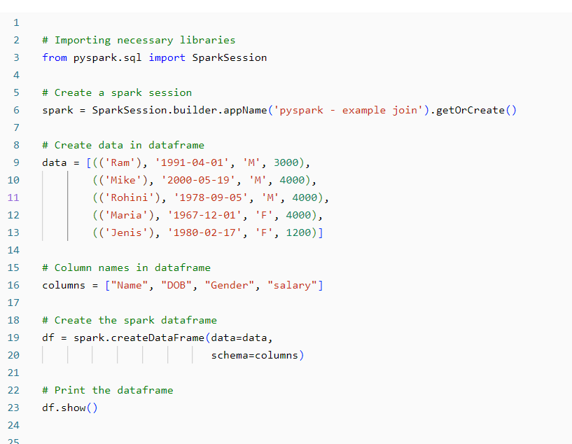

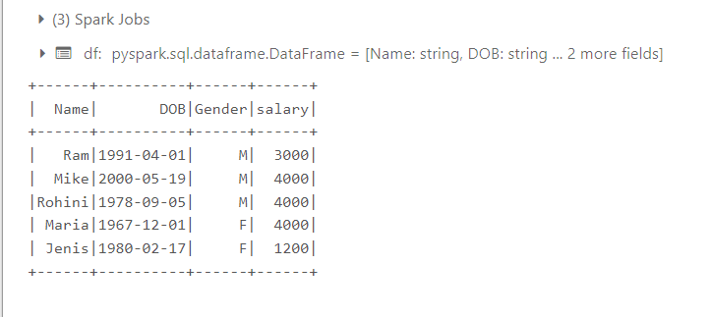

**Different method to rename**

1. **Using withColumnRenamed() method**

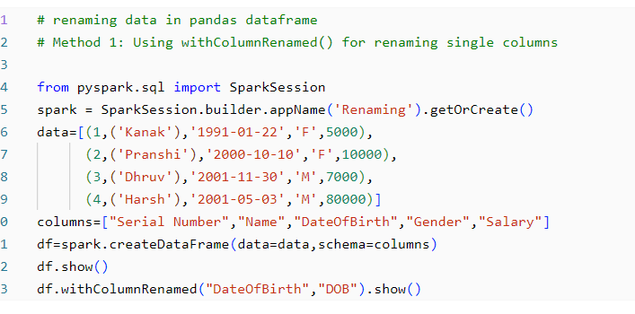

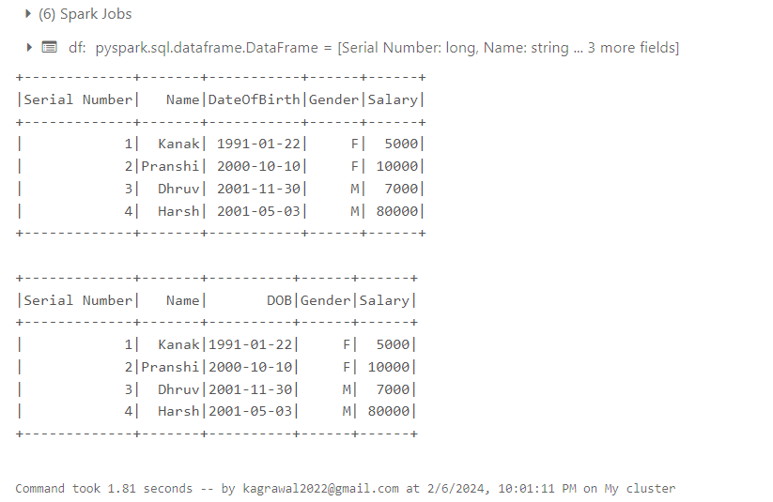

**Renaming multiple column using withColumnRenamed**

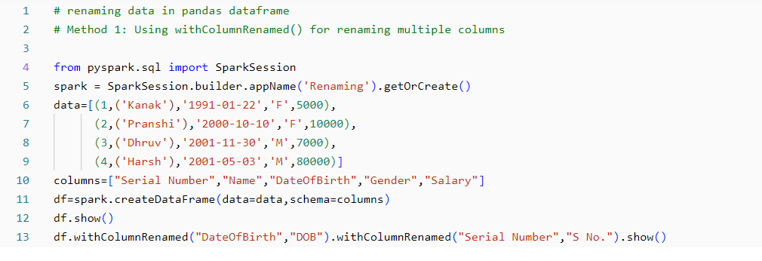

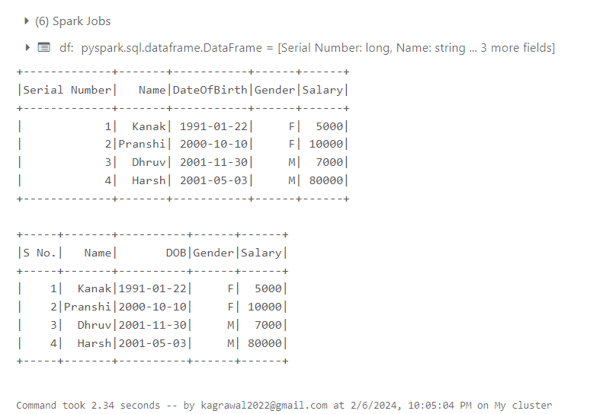

1. **Using select () Method**

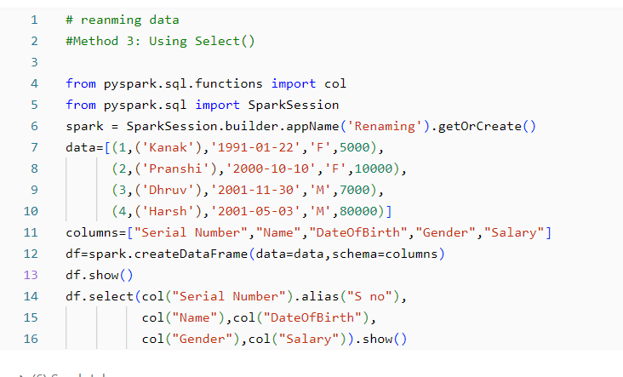

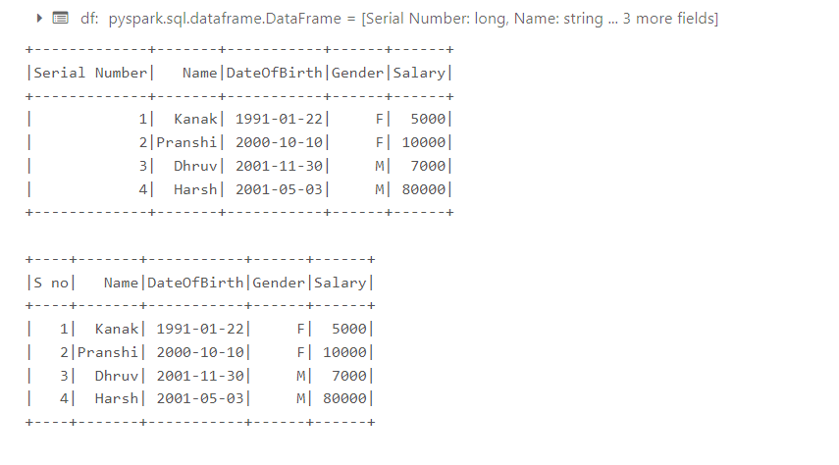

1. **Using toDF() method**

